Bash scripting
- Watch the video and write down notes
Watched the bash scripting and wrote down the notes with clear explanation
- Execute all scripts shown in video and capture the screenshots
To start the process
In aws start the instance and connect to the root user
To create script for sample
Vi test
#!/bin/bash
Free -m
Ps -ef
Df
To add permission
Chmod 777 test
./test we need to use for executing
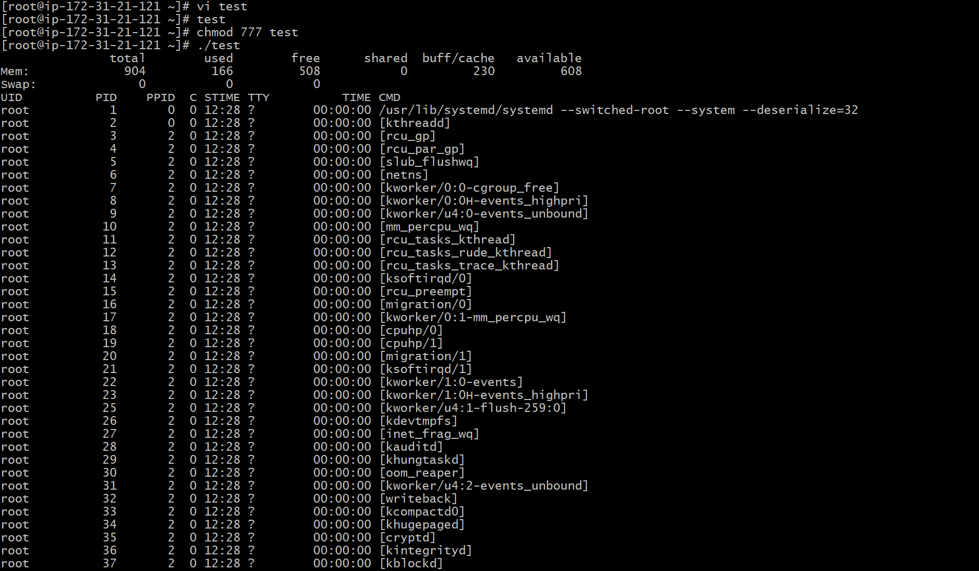
To create scipt with name Prashanth/scripts
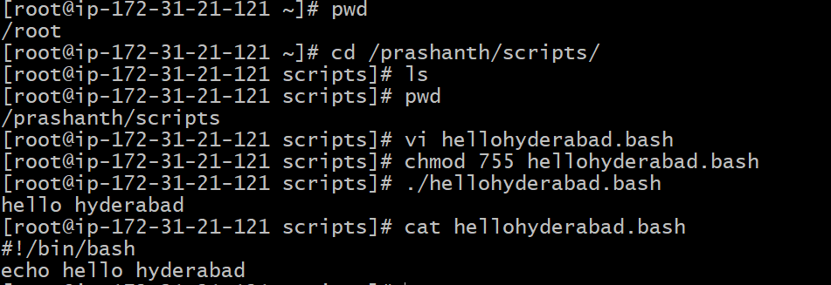

To execute commands bash
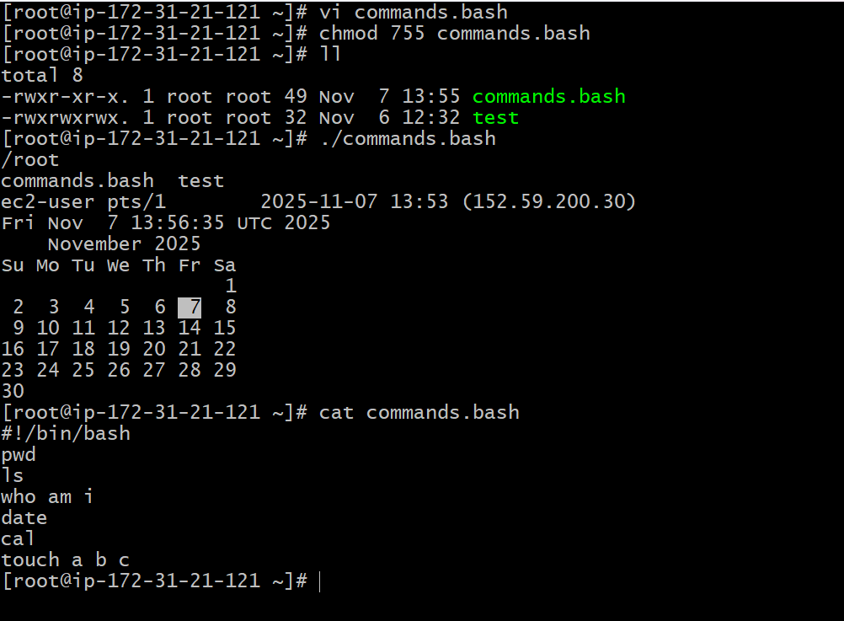

Basic administration task
Top
Df -h
Free -m
Uptime
Istat
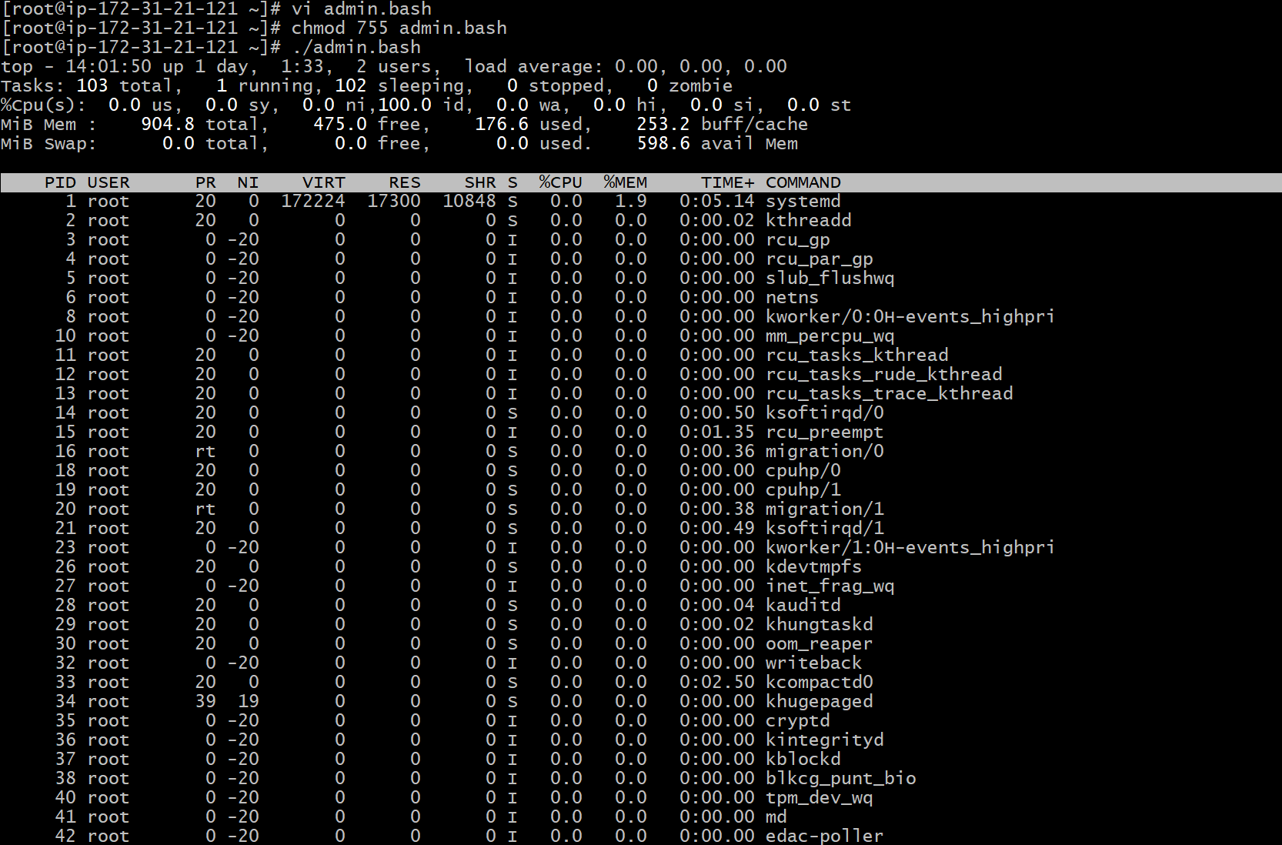
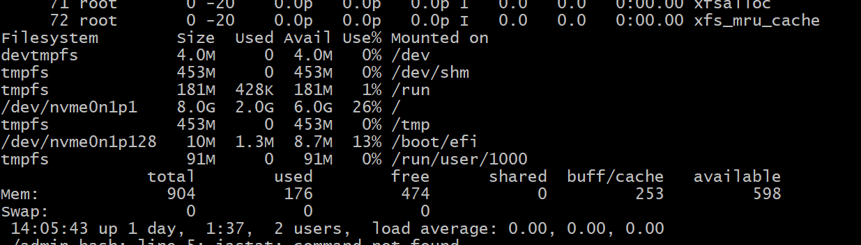
Defining variables
A variable is essentially a named container that holds a value which can be changed or varied during the execution of a program
Vi variables.bash
#!bin/bash echo Run variables tasks
#Define variables echo
P=pwd $p
L=ls $l
Wi=whoami $wi
D=date $d
C=’cal 2025’ $c
Chmod 755 variables.bash
./variables.bash

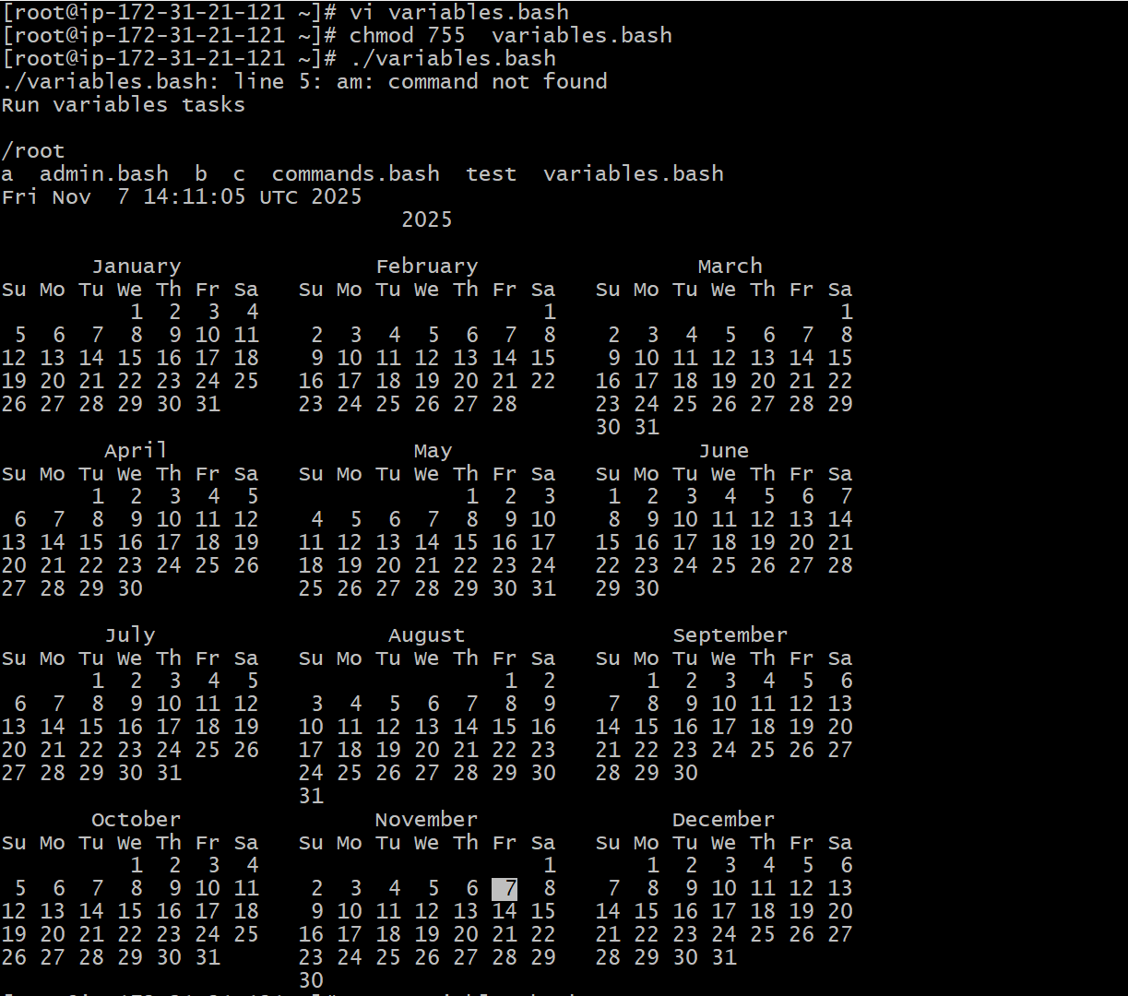

Input / output scripts
Read- to take command from user
Echo- to print the output
Vi input.bash continue from left
#!bin/bash echo
Echo,Hello, my name is Prashanth echo Hello$name
Echo echo
Echo what is your name? chmod 755 input.bash
Read name ./input.bash
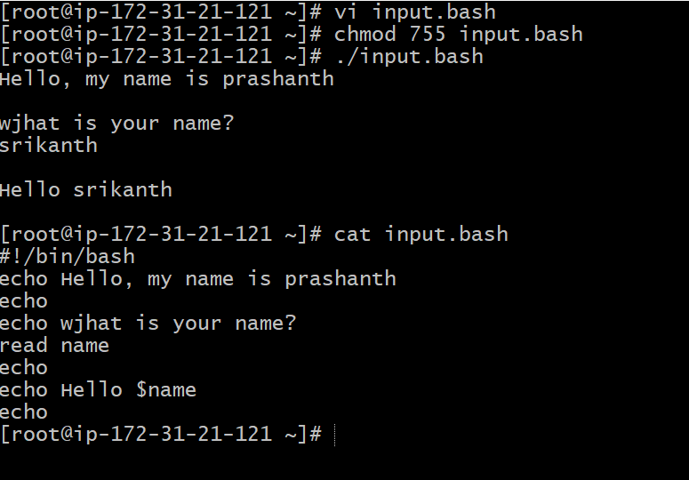
hostname bash
Vi output.bash
#!bin/bash
#we need to use the ticks if you want to use this in echo or else not required
a=hostname
echo Hello, my name is $a
echo
echo what is your name?
read b
echo
echo Hello $b
echo
